**Hamiltonian Graph-**

A Hamiltonian graph may be defined as-

|  |
| --- |
| If there exists a closed walk in the connected graph that visits every vertex of the graph exactly once  (except starting vertex) without repeating the edges,  then such a graph is called as a Hamiltonian graph.  **OR**  Any connected graph that contains a Hamiltonian circuit is called as a Hamiltonian Graph. |

### ****Hamiltonian Graph Example-****

The following graph is an example of a Hamiltonian graph-

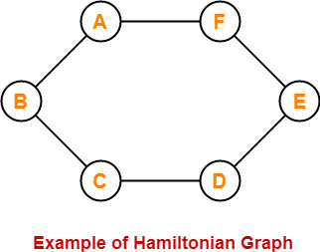

Here,

* This graph contains a closed walk ABCDEFA.
* It visits every vertex of the graph exactly once except starting vertex.
* The edges are not repeated during the walk.
* Therefore, it is a Hamiltonian graph.

Alternatively, there exists a Hamiltonian circuit ABCDEFA in the above graph, therefore it is a Hamiltonian graph.

## ****Hamiltonian Path-****

* If there exists a walk in the connected graph that visits every vertex of the graph exactly once without repeating the edges, then such a walk is called as a Hamiltonian path.

**OR**

* If there exists a [**Path**](https://www.gatevidyalay.com/walk-in-graph-theory/) in the connected graph that contains all the vertices of the graph, then such a path is called as a Hamiltonian path.

|  |
| --- |
| ****NOTE**** In Hamiltonian path, all the edges may or may not be covered but edges must not repeat. |

### ****Hamiltonian Path Examples-****

Examples of Hamiltonian path are as follows-

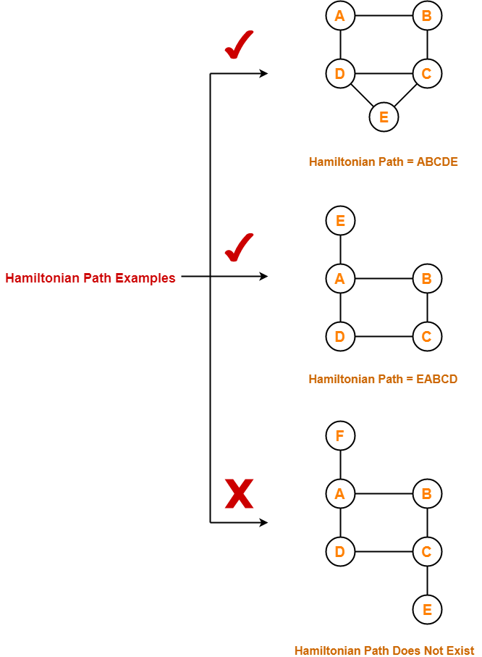

## ****Hamiltonian Circuit-****

Hamiltonian circuit is also known as **Hamiltonian Cycle**.

* If there exists a walk in the connected graph that visits every vertex of the graph exactly once (except starting vertex) without repeating the edges and returns to the starting vertex, then such a walk is called as a Hamiltonian circuit.

**OR**

* If there exists a [**Cycle**](https://www.gatevidyalay.com/walk-in-graph-theory/) in the connected graph that contains all the vertices of the graph, then that cycle is called as a Hamiltonian circuit.

**OR**

* A Hamiltonian path which starts and ends at the same vertex is called as a Hamiltonian circuit.

**OR**

* A closed Hamiltonian path is called as a Hamiltonian circuit.

### ****Hamiltonian Circuit Examples-****

Examples of Hamiltonian circuit are as follows-

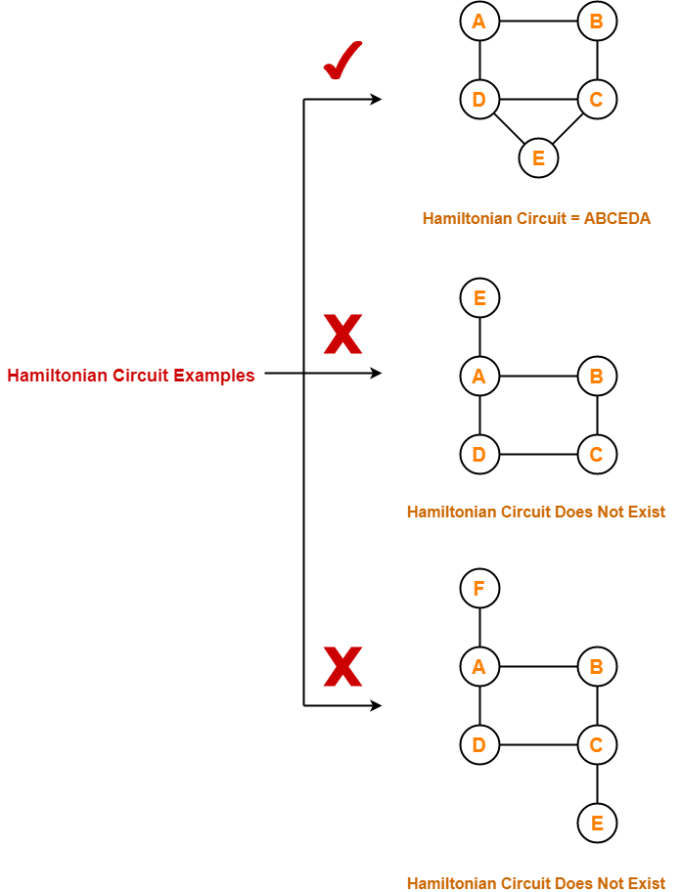

## ****Important Notes-****

* Any Hamiltonian circuit can be converted to a Hamiltonian path by removing one of its edges.
* Every graph that contains a Hamiltonian circuit also contains a Hamiltonian path but vice versa is not true.
* There may exist more than one Hamiltonian paths and Hamiltonian circuits in a graph.

## ****PRACTICE PROBLEMS BASED ON HAMILTONIAN GRAPHS IN GRAPH THEORY-****

## ****Problems-****

Which of the following is / are Hamiltonian graphs?

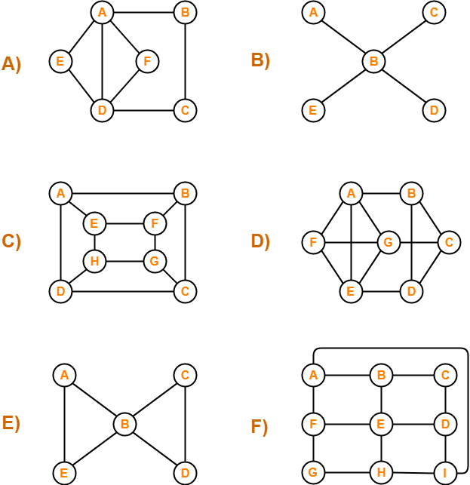

## ****Solutions-****

### ****A)****

The graph neither contains a Hamiltonian path nor it contains a Hamiltonian circuit.

Since graph does not contain a Hamiltonian circuit, therefore **It is not a Hamiltonian Graph**.

### ****B)****

The graph neither contains a Hamiltonian path nor it contains a Hamiltonian circuit.

Since graph does not contain a Hamiltonian circuit, therefore**It is not a Hamiltonian Graph**.

### ****C)****

The graph contains both a Hamiltonian path (ABCDHGFE) and a Hamiltonian circuit (ABCDHGFEA).

Since graph contains a Hamiltonian circuit, therefore **It is a Hamiltonian Graph**.

### ****D)****

The graph contains both a Hamiltonian path (ABCDEFG) and a Hamiltonian circuit (ABCDEFGA).

Since graph contains a Hamiltonian circuit, therefore **It is a Hamiltonian Graph**.

### ****E)****

The graph neither contains a Hamiltonian path nor it contains a Hamiltonian circuit.

Since graph does not contain a Hamiltonian circuit, therefore **It is not a Hamiltonian Graph**.

### ****F)****

The graph contains both a Hamiltonian path (ABCDEFGHI) and a Hamiltonian circuit (ABCDEFGHIA)

Since graph contains a Hamiltonian circuit, therefore **It is a Hamiltonian Graph**.